Long Island Sees Upswing in Immigrants
By JOSEPH DE AVILA

OCTOBER 27, 2011

Long Island's immigrant population has more than doubled in the past three decades, with nearly one in five Long Islanders now born abroad, according to a new report released on Thursday.

About a third of all immigrants on Long Island are now Hispanic, making it the biggest group of foreign-born Long Islanders, according to a report by the left-leaning Fiscal Policy Institute based on U.S. Census Bureau data. But an influx of Asians has also helped change the demographics of Nassau and Suffolk counties, two of the nation's wealthiest suburbs.
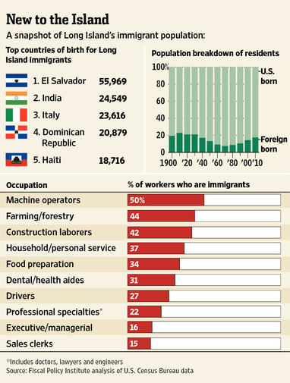
The report highlights how immigration trends in the New York City suburbs have been shifting for decades. Generations ago, immigrants came to areas such as Manhattan's Lower East Side to begin new lives before leaving for Long Island.

"Nowadays they are moving directly to the suburbs," said Lawrence Levy, executive dean at Hofstra University's National Center for Suburban Studies.

Today, Pakistanis are flocking to the town of Brookhaven; Koreans are coming to Oyster Bay and Glen Cove; and Ecuadorians are settling in Hempstead.

Hispanics from Central America have emerged as the biggest groups of new immigrants on Long Island. El Salvadorans were the largest immigrant group, increasing their ranks by 27% to nearly 56,000 between 2000 and 2009.

El Salvador's civil war in the 1980s and early 1990s, followed by social upheaval there, fueled the wave of emigration, said Patrick Young, an attorney with the Central American Refugee Center.

Now "there is almost no village on Long Island that doesn't have a small population of Salvadorans," Mr. Young said.

The Village of Hempstead remains an epicenter for many Central Americans. In the downtown area, the streetscape is lined with Salvadoran restaurants and bakeries, travel agencies specializing in flights to Central America and check-cashing vendors where immigrants can send remittances to their families back home.

Delmis Avella, who owns a clothing store downtown, came to Hempstead in 1993 from El Salvador. Her mother and sister arrived in Long Island with political asylum during the early 1980s. "I wanted to change my life," said Ms. Avella, 36 years old.

Ms. Avella says she has no intention of ever returning to El Salvador due to its gang problems. "It's too dangerous," said Ms. Avella, a mother of three.

Leslie Esperanza Rivera, 32, moved to Hempstead from Honduras a year ago to join her husband. She works in a clothing store in downtown Hempstead and sends money home to put her three children, who are still in Honduras, through school. Her husband works in a nearby pizzeria.

"It's better to come here and save money," said Ms. Rivera, who plans to stay in the U.S. for about another two years before returning to Honduras. "That's where my family is."

Jobs and family connections are the main reasons why immigrants have chosen Long Island for their home, Mr. Levy said, though the rate of immigration has slowed since the economic downturn began.

The report presents a complicated portrait of where immigrants work and how they contribute to the economy, said David Dyssegaard Kallick of the Fiscal Policy Institute.

Indians, who grew by 26% since 2000 on Long Island, and Filipinos, who surged 45%, primarily work in white-collar jobs such as engineering and teaching. Groups from Latin America—heavily represented by countries in Central America—are more likely to work in low-skilled jobs. Meanwhile, foreign-born Long Islanders own nearly a quarter of all small businesses in Nassau and Suffolk.

"There is no typical immigrant," Mr. Kallick said. "What you see is that the composite of immigration turns out to be a very robust picture of immigrant contribution with a lot of range."

While many immigrants come to Long Island for higher wages, they earn about a quarter less than U.S.-born workers. Immigrant families, however, earn only 11% less than U.S.-born families, mostly because foreign-born households tend to have more than two wage earners, the report said.

"I think the report debunks the popular stereotypes of Long Island immigrants," said Pearl Kamer, chief economist of the Long Island Association. Much of the political discussion around immigration on Long Island focuses on illegal immigration and ignores contributions made by foreign-born residents, she added.

Others criticized the report. "It doesn't...determine the costs of services that immigrants use in the economy," said Seth Forman, of the Long Island Regional Planning Council.

The report also doesn't distinguish between new immigrants and those who arrived in the country decades ago, Mr. Forman said. "I think that most people are concerned about present day immigration," he added.

